**Multimeter**

Application Project 2



ENEL 511 - Embedded System Interfacing

**Lab B02 Group 10 Members:**

Dan Tran - 30050533

Justin Nguyen - 30042258

Nathan Tham - 30046119

**Professor:**

Jaspreet Kaur

**State Diagram**

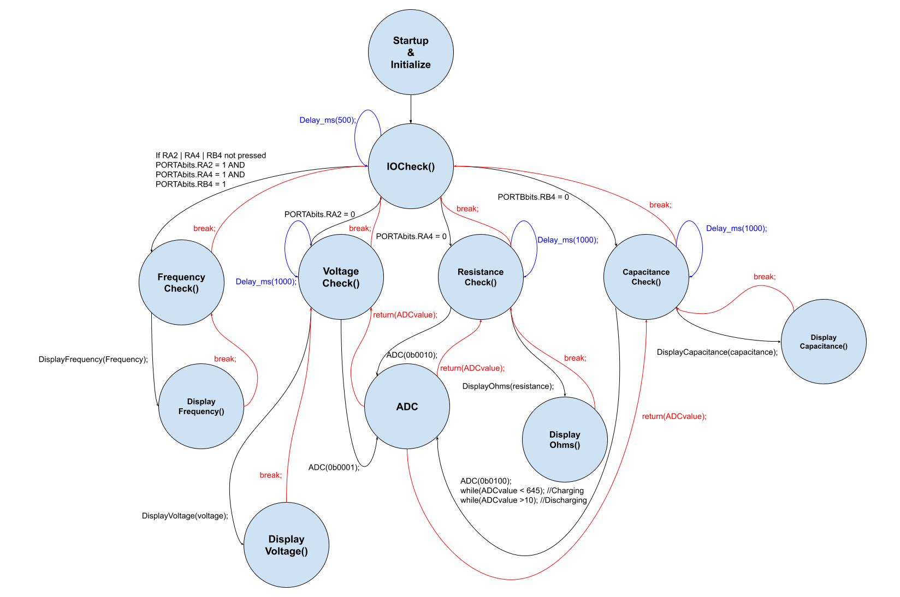

**Mathematical Formulas**

Voltmeter: $V = ADCvalue * Vres$

$ADCvalue: ADCBUF (From ADC pin 8), Vres: 0.00313 (V)$

Ohmmeter: $R_{2} = R_{1} * \frac{1}{(\frac{Vin}{Vout}-1)}$

$R_{1}= 1000 Ω, Vin = 3.25V, Vout = ADCvalue*Vres$

$ADCvalue: ADCBUF (From ADC pin 15), Vres: 0.00313 (V)$

Capacitance: $C = \frac{τ}{R}$

$τ: Time constant (time taken to charge capacitor), R: Resistance (1000 Ω)$

$The above equation is true when τ = RC$

$Vo (τ=RC) = 0.63*Vref$

$Vout = ADCvalue*Vres, Vref = 3.25V$

$ADCvalue: ADCBUF (From ADC pin 5)$

**Maximum/Minimum Limits**

Voltage: Max: 3.25 V Min: 0 V

Resistance: Max: ~50,000 Ω Min: >0 Ω

Capacitance: Max: 470 $μF$ Min: 1nF

Frequency: Max: 6387 Hz Min: 255.5 Hz

**Workload**

1. Justin Nguyen
   1. Tested microcontroller code
   2. Helped with programming logic
2. Dan Tran
   1. Tested microcontroller code
   2. Primary logic development
3. Nathan Tham
   1. Tested microcontroller code
   2. State Diagram
   3. Record video